

Challenge de la Singerie

Switzerland October 2023

The K1 is an actively growing class throughout the UK with 180+ boats now registered. The reputation of the K1 dinghy as a fast stable boat has spread far and wide with owners as far flung as USA and Australia.
We are also developing the class in in Europe and it happens that we have a sole K1 owner in Switzerland, Julian Marewski, #172, with whom I have been in close correspondence. As he has nobody to ask for help and advice in Switzerland, I seemed take on the role of advisor, for what it is worth!
Julian progressed very well with his K1 and started winning local regattas at his club in Lutry near Lausanne on Lake Geneva, to the extent that he invited me participate in one of these. In a moment of madness I agreed to travel down to Switzerland to participate in the “Challenge de la Singerie” - the “Monkey House Challenge” ( loosely translated) in October. (The “Monkey House” being the name of their clubhouse):
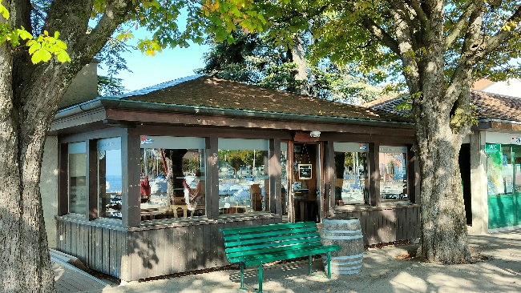
La Singerie

So, I set off on 4th October, boat packed up with trailer fully serviced and new towing top cover. I took the midday crossing of Eurostar Le Shuttle to Calais, drove down the A26 autoroute to Reims, spending the night in the Ibis Budget at the Parc des Expositions. Found parking space for the boat in the car park fairly easily.
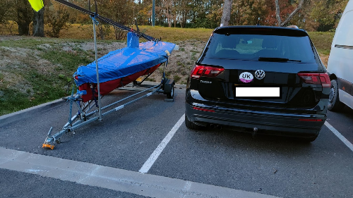
Ibis Car Park
Had a good meal at the Mercure hotel next door (slightly more up-market) and then continued next day after continental breakfast at the hotel. Continued down the autoroute towards Besançon and then through the mountains via Pontarlier, to avoid the tolls on the Swiss motorway arriving late afternoon. Unpacked the boat and checked into the Hotel du Rivage right on the waterfront nearby.
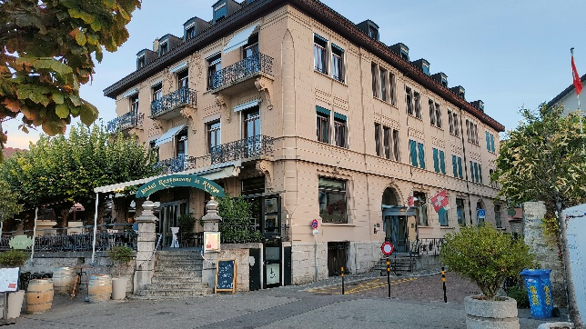
Hotel du Rivage on lakeside
Then met up with Julian in the evening.
As I had a day to spare, decided to have a look around the local area and catch a bus into Lausanne itself. Lutry is a small village/suburb about three or four miles from the Lausanne. Fortunately, the weather was very warm, although little wind. With beautiful views over the lake:

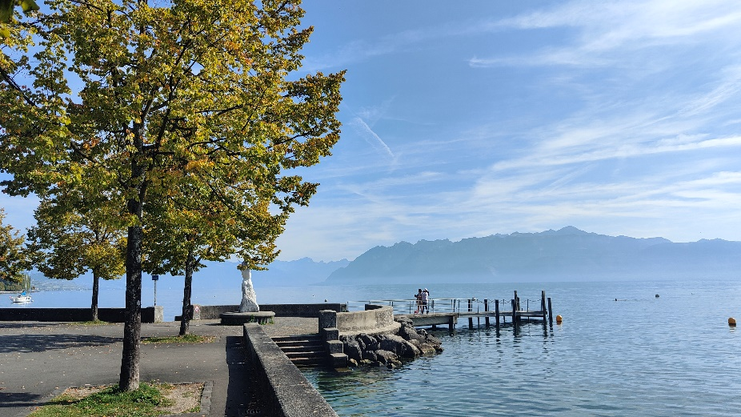
Lakeside promenade

The next day, Saturday 7th. October was the start of the series. I was greeted by Benoit, Commodore of the Club, with a mutual exchange of pennants!
Winds were very light and there was a postponement until well after midday and even them the wind was only Force 1 at best with thermals. We managed to get just one race in and somehow, I managed to be second over the line, beating two 470s and a D-Zero with Julian coming first. There were roughly 12 entrants with competitors from nearby clubs in Pully and Valée de Joux.
I found the course a bit strange, described in the Sailing Instructions as “la banane” – banana. I took this to mean a simple windward-leeward course but when I got to the start line, I discovered that there was no pin-end and the leeward mark was being used with the committee boat to form the line instead. So as a result of this, the leeward mark was displaced to port. It became more of a broad reach down from the top mark and then you could almost lay the top mark going back up again on the beat! The finish was a dead run down from the top mark, so the course was a sort of banana in shape! Apparently, this is common practice, possibly due to the depth of the lake making it difficult to lay too many marks.
The second day had an earlier start to take advantage of the thermals and possibly also “la bise” – the wind coming down from the mountains. We managed to get two races in. I came second and third over the line respectively with Julian coming first in both. The final result was a clean sweep for the K1s with Julian coming first and myself second! An incredible result as I am usually very poor in light winds.
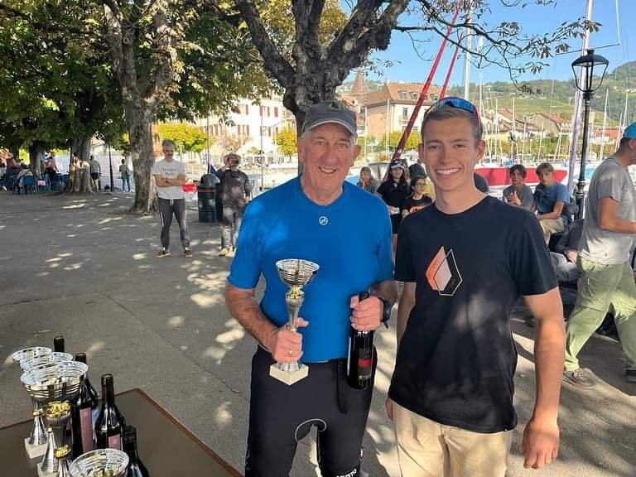
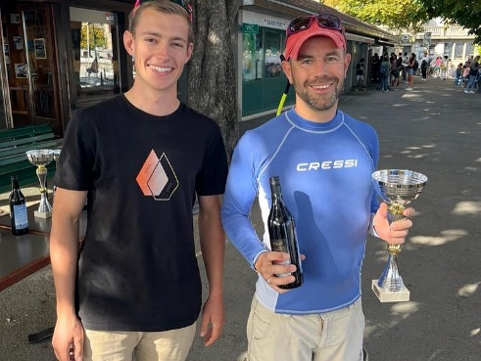
DP Prizegiving
Julian Prizegiving

The journey home was uneventful, stopping again in Reims overnight, arriving back in the UK on Tuesday 10TH. A thoroughly enjoyable trip with great scenery and friendly people. Well worth a second visit if only for the scenery and the ambiance.

David Pritchett K1 159

More photos
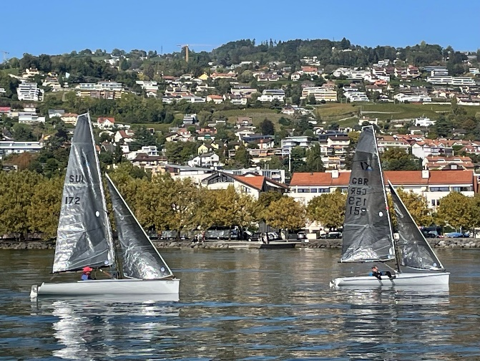
K1s on Lake Geneva
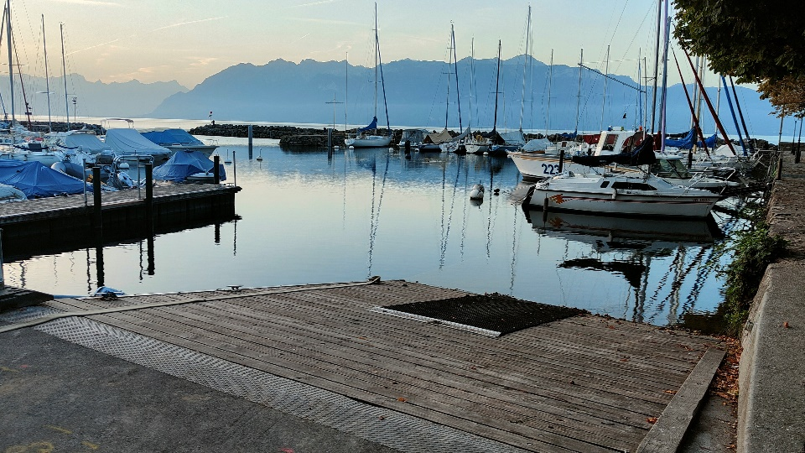
The port at Lutry
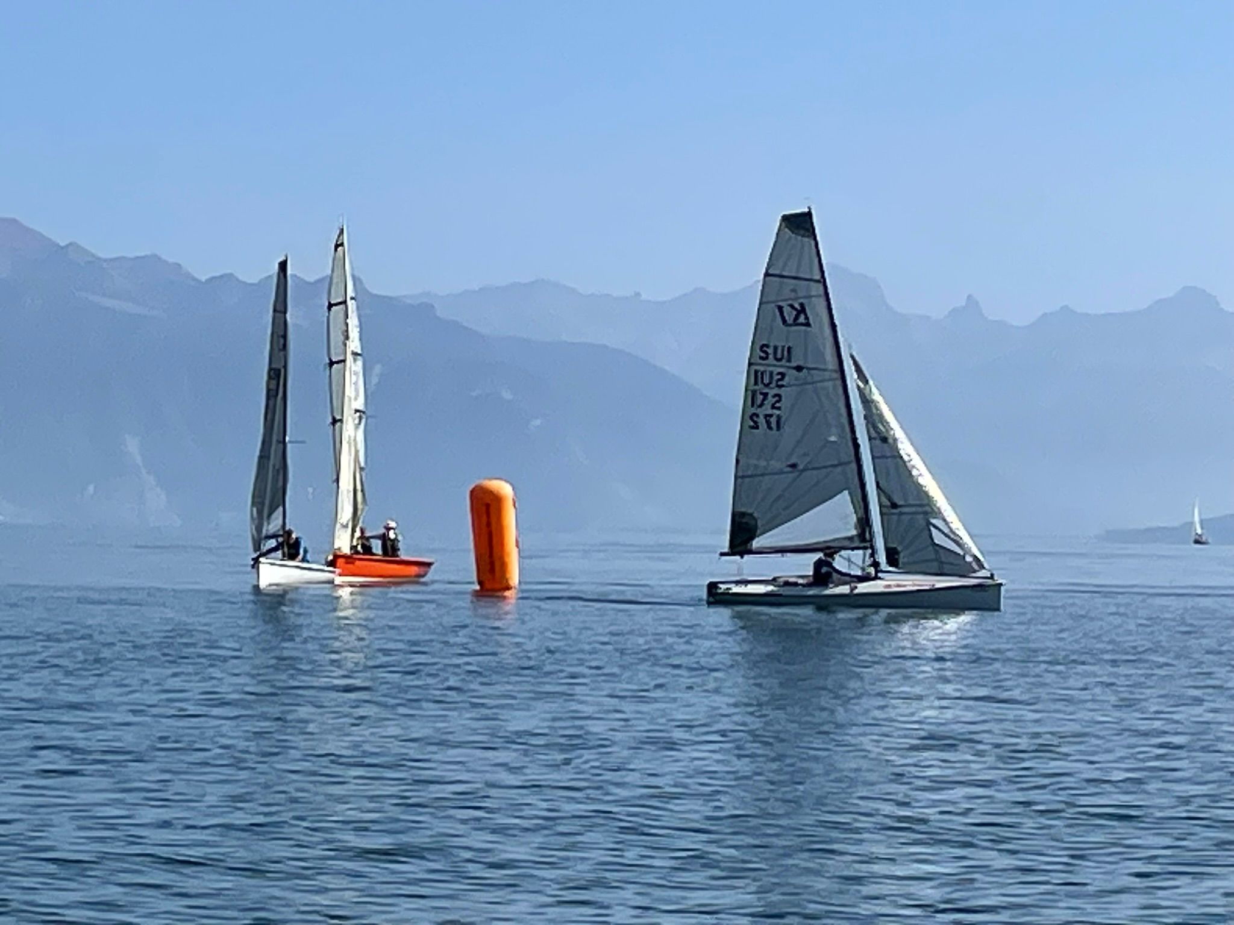
Rounding the mark
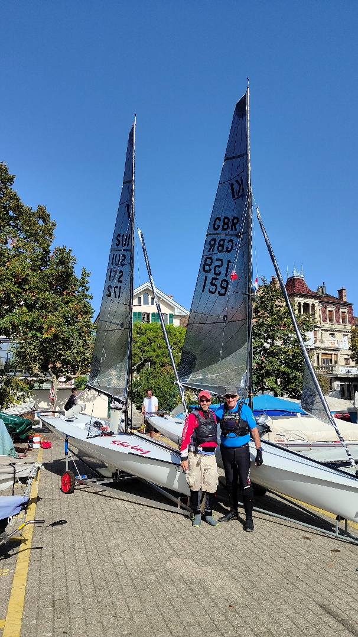
K1s ready to go!
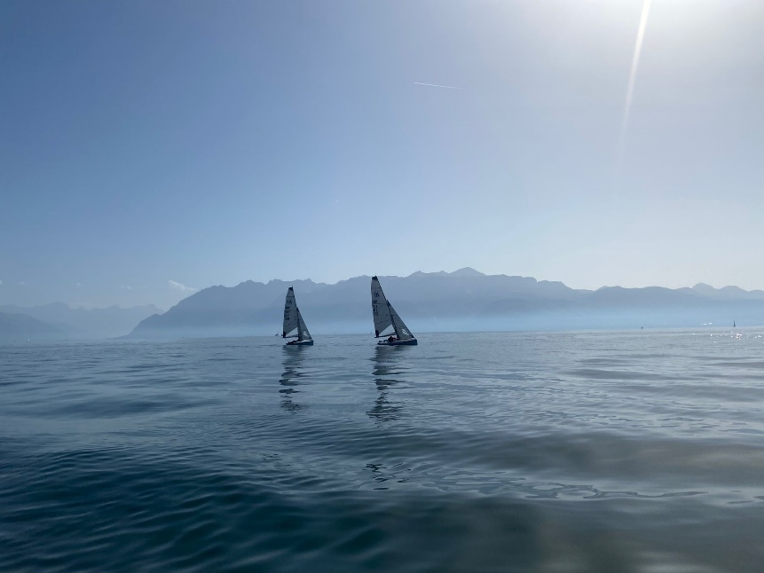
Hazy afternoon

More Information:
The Club Nautique de Lutry is a small friendly club situated about 3 miles east of Lausanne on Lake Geneva. Specialises in training and various regattas and social sailing events during the summer (“Petites Semaines”). About 350 members. Most seem to do keelboat sailing. A popular class is the “Surprise” , similar to a Squib.
Facebook: https://www.facebook.com/ClubNautiqueDeLutry/
Website: Ecole de voile | Club Nautique de Lutry | www.cnlutry.ch/navig
French is the normal language used although many speak English (Julian is fluent in English).
Lutry is a small village now absorbed within the city of Lausanne. There are good bus and rail links into Lausanne and also along the coast. There is a promenade along the shore with a swimming area.

Approx costs:
Ferry: £450
Diesel £200
Motorway tolls in France: £150.
(I use an Emovis electronic tag for the automated lane. Easier when driving a right-hand drive car alone! Didn’t bother to get a “vignette” for the Swiss motorways as it is only a short distance over the border form France. And you have to buy one for the trailer as well!)
Hotel du Rivage £125 per night
Ibis Budget £70 per night.

